**Programme: BSc**

**Semester: III**

**Course Name: Web Design**

**Roll No.: SU190175**

**CA-I: Assignment**

**Image Optimization**

1. **Adding Simple and Descriptive Name of The Image.**

Descriptive naming of a file plays an important role in the image optimization and overall search of the website because search engines not only looks for text on the website, they also seek for file name provided for the image.

**Mini project example:**

* When the image was downloaded the image file name was as you can see in the bellow picture which doesn’t make any sense.

**Previous Image File Name:**



* I optimized the image by giving a pain and descriptive file name to the image in the below example.

**Renamed Image file name**:



**HTML Code:**



Think about it, if your image dint have any **alt** attribute, no title and random file name (e.g. hush-naidoo-yo01Z-9HQAw-unsplash.jpg) how would google recognize what the image is about?

so, changing the image file name makes it better for search engines to recommend your website because the more clues you give to google, the more it can figure out what the site is about.

1. **Optimization of Your alt Attribute**

The **alt** attribute is displayed as alternate text for an image which cannot be displayed for some reasons like errors in src attribute, net speed etc. Even when the image is displayed an if u hover over it, it will display the text you had entered in your **alt** attribute.

Adding relevant and appropriate **alt** attributes to your images can also help you rank better on search engines. This is probably one of the best ways for your image to show up in google images and web searches.

So, filling out each alt attribute for all the images is one of the key ways for optimizing images on your site.

Some simple rules that can be followed are using plain and simple text, the way we used in the images and also not stuffing too much text in your alt attribute.

**Mini Project Example:**

* First, I had used just “we care” as the alt attribute without knowing much about it.

**Original alt attribute:**



* I optimized it by changing the alt attribute to “Red blood cells”.

**Optimized alt attribute:**



**Image On My Website:**

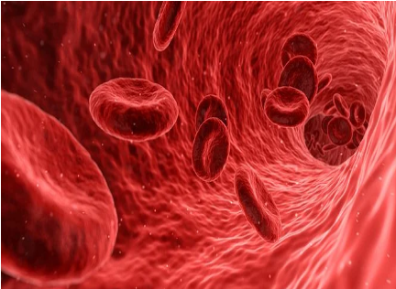

1. **Reducing Image File Size**

Size of the image files play a key role in loading of the image on the websites. If the size of the image files is too large, the longer it takes for the image to load, whereas when the image size is less, less amount of time is taken to load.

Imagin your waiting for a site to load everything and if it takes 10-15 sec for a site to load, the user won’t wait for too long and would want to jump to some other site.

whereas, if the site takes just 4-5 sec to load everything the customer will be more pleased to stay.

So, reducing the image file size helps in loading the image faster hence making the user more efficient to browse through the site.

**Mini Project Example:**

* The Actual size of the image was 1.13MB and it took 2-3 secs for the image to load on my website.

**CSS code:**



**The Actual Image:**

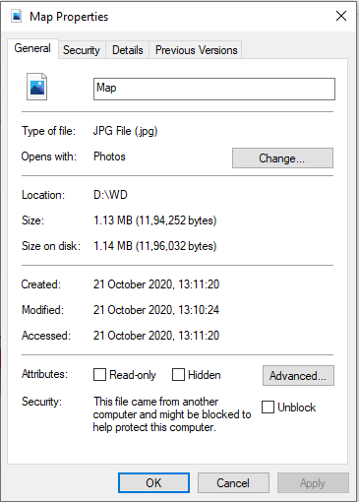 

* The resized image is 808KB and it took just 1 sec to load. This shows how reducing the size of an image can help the website to load the image faster.

**CSS code:**



**After Resizing The Image:**

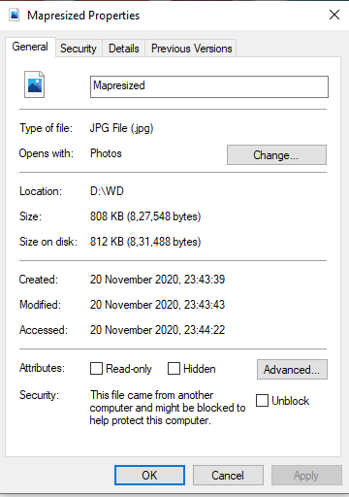

1. **Choosing the right file type**

Having a proper file type for the image also helps in optimizing the image better.

There are basically 3 common file types for an image that I would like to take, that are PNG, JPEG or JPG and GIF.

**PNGs (Portable Network Graphics):**

They are as popular as JPEGs. they are used when there is less amount of color details in the image. Which also reduces the size of the image. If you save the image with more color details in PNG format it will be heavier than the image stored in the JPEGs format. It can be used for logo and icons in particular because it supports transparency.

**Mini Project Example:**

I have used PNG format for my logo and icons because there no much colors in these images and also because of the advantage of transparency.

**Logo:**





**Next Icon:**





**Start Icon:**





**JPEG or JPG (Joint Photographic Experts Group):**

The JPEG or JPG file formats are used when the image contains lots of colors in it, as the main benefit of this formats are that it can display millions of colors and it can withstand high compression levels.

After compression of the image in this format there are slight quality drops that can be noticed if u watch carefully but they are not often noticeable.

**Mini Project Example:**

I have used this format in my background images because it had many colors in it.

even after compressing the image (in my example above (3 point)), it dint make much difference to the quality of the image as you can see in the bellow example 1.

**Background image 1:**





**CSS Code:**



**Background image 2:**





**HTML Code:**



**GIF (Graphics Interchange Format):**

Mostly this format is used to showcase animations or static GIF images.

The file format that we have discussed above don’t generally support animations.

This type of image weighs a lot because they contain many frames.

We can optimize the GIF files but the output won’t be as good as the formats that we discussed above.

GIFs support only 256 colors and transparency which decrease the quality and also increasing the size of the file which is not preferred for optimizing an image.

**Mini Project Example:**

I dint use any GIF on my website because I dint felt any need of it in my project but I would like to show you a static GIF image example.

**Static GIF image:**



Basically, we can say that JPEG or JPG format should be used in an image file when there are more colors in the image and if there is any need of compression of the image. this format can be preferred for almost all image.

whereas PNG format should be used for logo and icons because those images contains less colors and transparency feature which gives an upper hand.

And lastly GIFs should be used only when an animation is required or for static GIF images.

**Teachers sign:**